[**TRAKYA ÜNİVERSİTELER BİRLİĞİ**](https://www.tub.gov.tr/)

**Elektronik Kaynak Eğitimleri-IV**

**(ProQuest EBook Central Eğitimi)**

**Çevrim İçi Seminerine Davetlisiniz.**

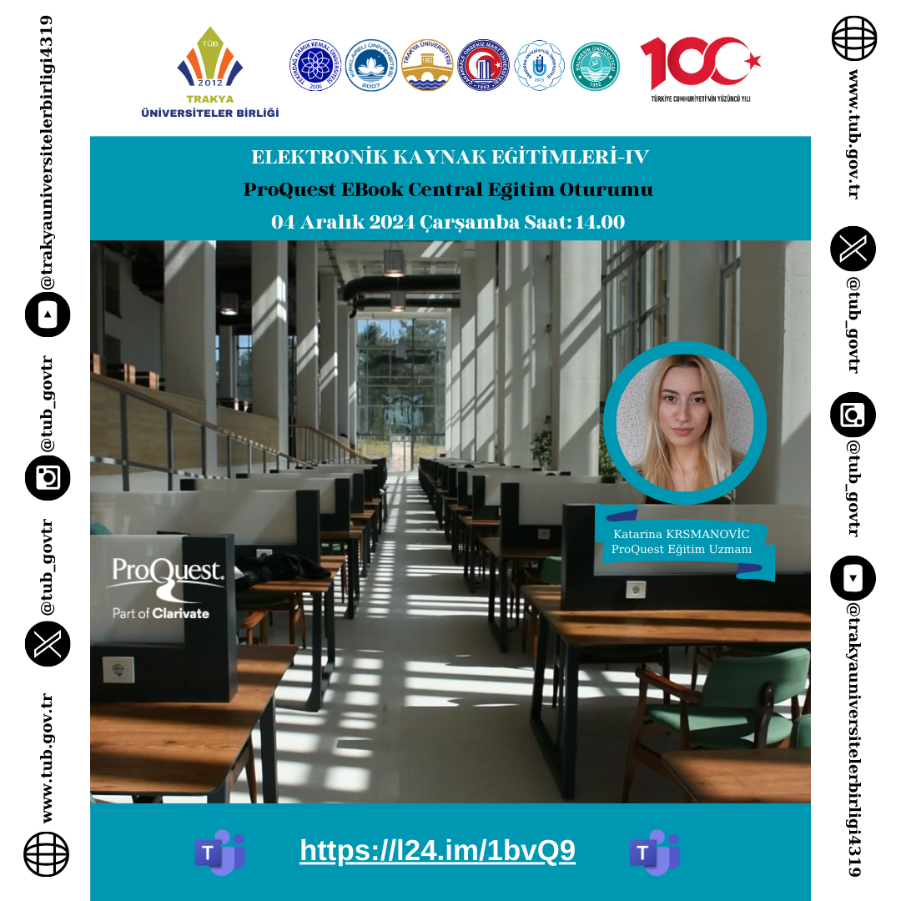

**Tarih: 04.12.2024     Saat: 14.00     Erişim Adresi:**[**https://l24.im/1bvQ9**](https://l24.im/1bvQ9)

**Alternatif Erişim Adresi:**[**https://events.teams.microsoft.com/event/2a1572e0-6c20-4978-88e7-a2274f3e3f0f@127fa96e-00b4-429e-95f9-72c2828437a4**](https://events.teams.microsoft.com/event/2a1572e0-6c20-4978-88e7-a2274f3e3f0f@127fa96e-00b4-429e-95f9-72c2828437a4)

-